**SENSORS AND MODULES**

**HUMIDITY SENSOR:**

**REQUIRED LIBRARIES:**

Pip install Adafruit_DHT.

pip install adafruit-circuitpython-bme280

sudo apt-get install python3-dev python3-pip

sudo python3 -m pip install --upgrade pip setuptools wheel

import Adafruit_DHT

import time

**circuit diagram:**

<https://www.thegeekpub.com/236867/using-the-dht11-temperature-sensor-with-the-raspberry-pi/>

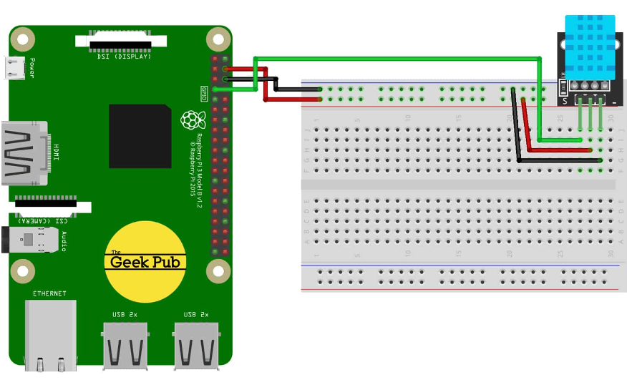

**Accelerometer sensor:**

Accelerometer sensors are commonly used to measure acceleration, tilt, and motion in electronic projects. The libraries required for interfacing with an accelerometer sensor depend on the specific sensor you are using and the microcontroller

**Required libraries:**

pip install mpu6050-raspberrypi

from mpu6050 import mpu6050

sudo raspi-config

sudo reboot

sudo apt-get update

sudo apt-get install python3-smbus

sudo apt-get install i2c-tools

sudo i2cdetect -y 1

**circuit diagram:**

<https://www.electronicwings.com/raspberry-pi/mpu6050-accelerometergyroscope-interfacing-with-raspberry-pi>

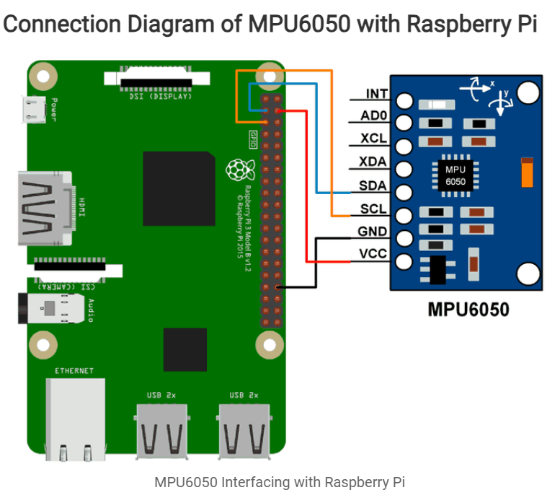

**Gyroscope Sensor:**

The libraries required for interfacing with a gyroscope sensor depend on the specific sensor you are using and the microcontroller or platform you are working.

**Required libraries:**

sudo apt-get update

sudo apt-get install python3-smbus

sudo apt-get install i2c-tools

pip install mpu6050-raspberrypi

**Circuit diagram:**

<https://ozzmaker.com/berryimu/>

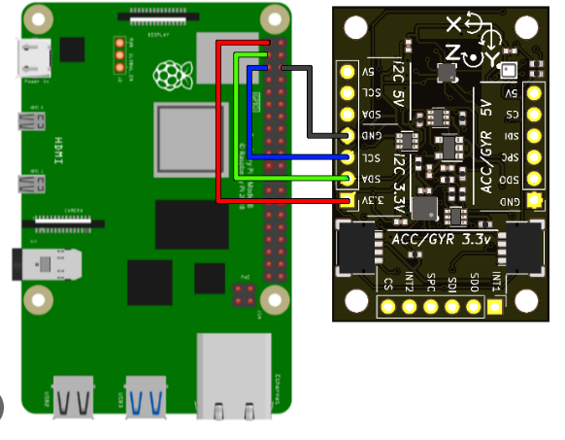

**MAGNOTOMETER SENSOR:**

**REQUIRED LIBRARIES:**

sudo apt-get update

sudo apt-get install python3-smbus

sudo apt-get install i2c-tools

pip install Adafruit_GPIO

pip install Adafruit-PCA9685

pip install adafruit-circuitpython-hmc5883l

import time

import board

import busio

import adafruit_hmc5883l

**CIRCUIT DIAGRAM:**

<https://www.electronicwings.com/raspberry-pi/triple-axis-magnetometer-hmc5883l-interfacing-with-raspberry-pi>

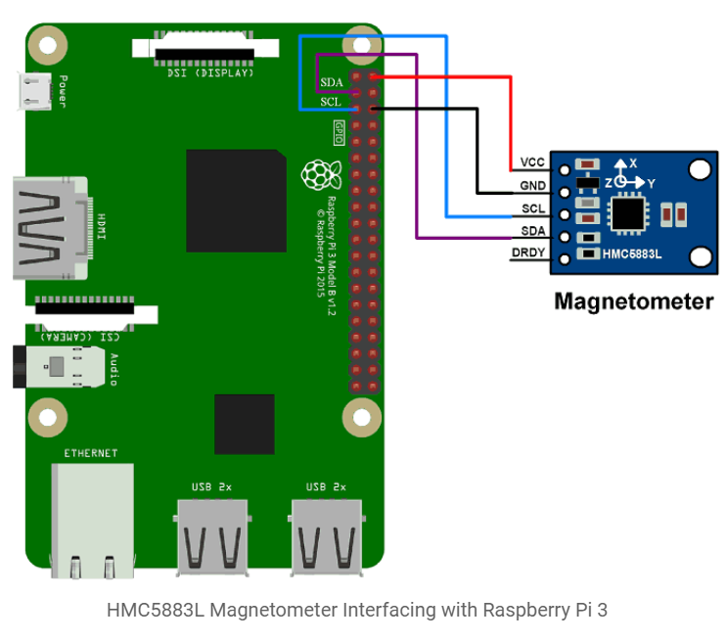

**ECG SENSOR:**

**Required library:**

pip install adafruit-blinka

pip install adafruit-circuitpython-ad8232

import time

import board

import busio

import adafruit_ad8232

# Create I2C bus

i2c = busio.I2C(board.SCL, board.SDA)

# Create sensor object

ecg = adafruit_ad8232.AD8232(i2c)

**circuit diagram:**

<https://www.hackster.io/phantom_override/building-a-electrocardiogram-with-windows-iot-and-azure-8b2b44>

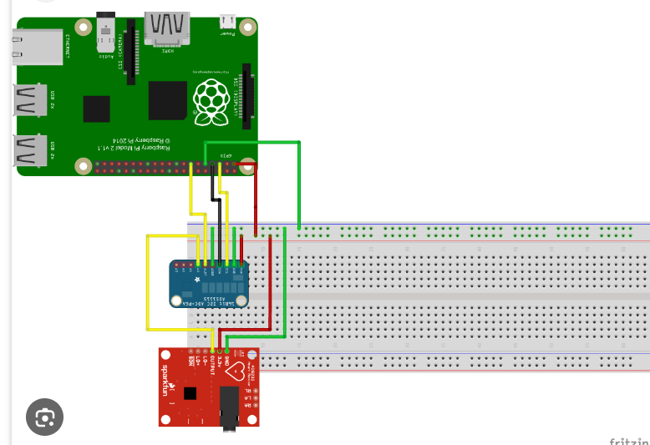

**Ultrasonic sensor:**

Ultrasonic sensors, such as the HC-SR04, are commonly used for distance measurement in electronic projects

**Required libraries:**

**HC-SR04 sensor.**

pip install RPi.GPIO

import RPi.GPIO as GPIO

import time

# Set GPIO pins

TRIG_PIN = 23

ECHO_PIN = 24

# Set GPIO mode and setup

GPIO.setmode(GPIO.BCM)

GPIO.setup(TRIG_PIN, GPIO.OUT)

GPIO.setup(ECHO_PIN, GPIO.IN)

**Circuit diagram:**

<https://www.electronicshub.org/raspberry-pi-ultrasonic-sensor-interface-tutorial/>

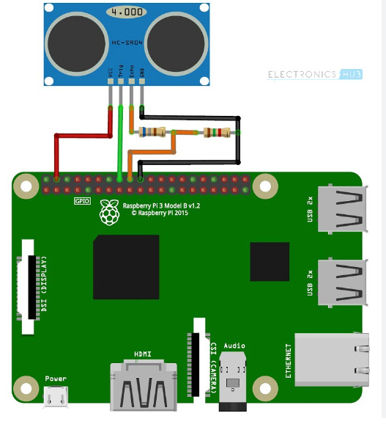

**PRESSURE SENSOR:**

**required libraries:**

pip install RPi.GPIO

sudo apt-get install python3-smbus

pip install spidev

import smbus

import time

# Configure I2C bus

bus = smbus.SMBus(1) # Use '0' for older Raspberry Pi boards

**circuit diagram:**

<https://pimylifeup.com/raspberry-pi-pressure-pad/>

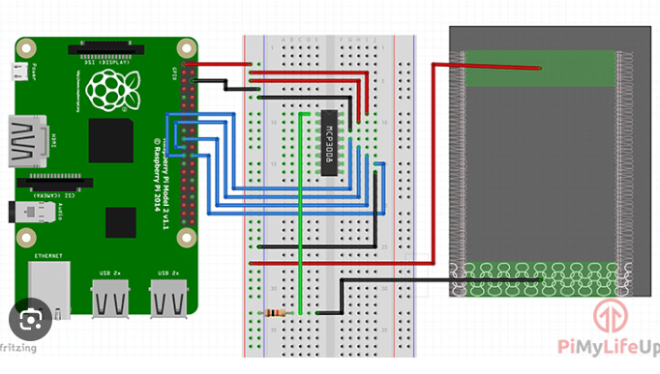

**COLOR SENSOR:**

The required library for a color sensor on a Raspberry Pi depends on the specific model of color sensor you are using. Two common color sensors are the TCS3200 and TCS34725.

**Required libraries:**

pip install adafruit-circuitpython-tcs34725

import RPi.GPIO as GPIO

import time

import board

import busio

import adafruit_tcs34725

**Circuit Diagram:**

<https://www.raspberrypi.com/news/colour-sensing-raspberry-pi/>

